Session 13
SIMPLE MOVING AVERAGE
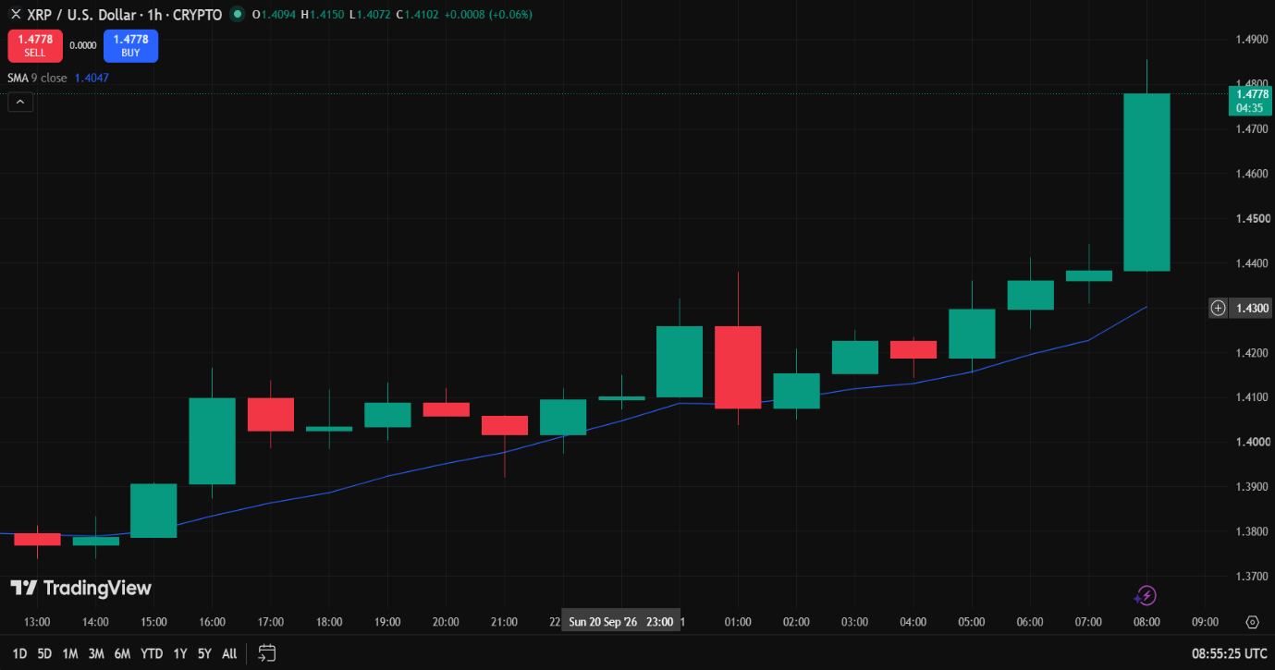
Session 14
RELATIVES STRENGTH INDEX
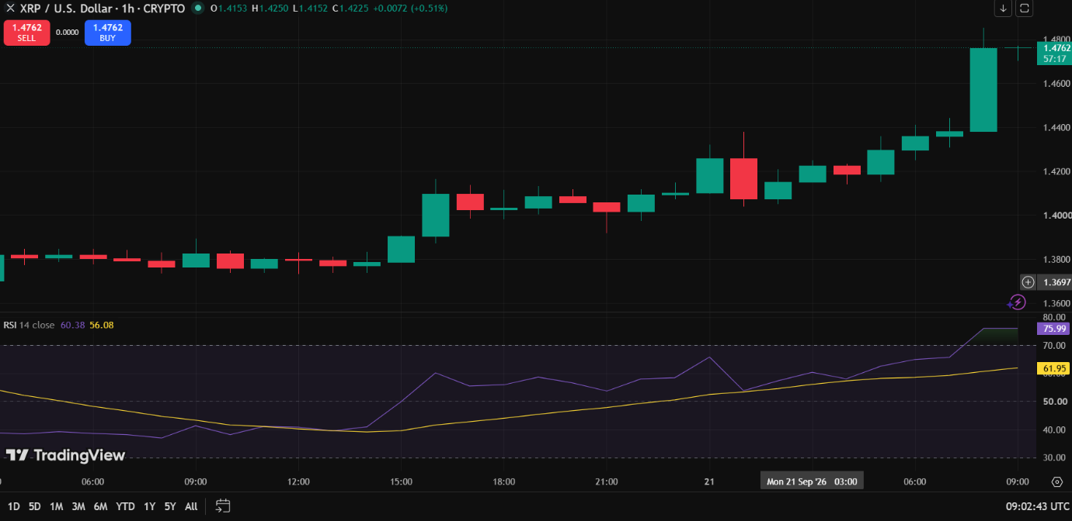
The RSI is 75.99, it is over brought so we can BUY.

Session 15
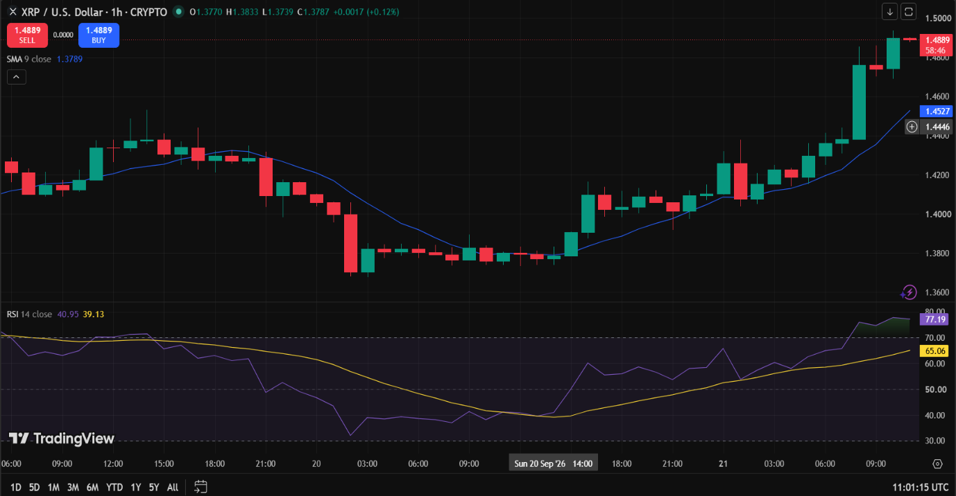
Indicator-Based Trading Report
Market Observation
Particular | Observation
Asset | XRP (XRPUSD)
Timeframe | 1 Hour (1H)
Price Position | Above 9 SMA
SMA Direction | Upward
Current RSI | 77.19
RSI Zone | Above 70

Trading Decision
Particular | Observation
Trade Executed | Yes
Trade Type | Long (Buy)
Reason | An RSI reading of 77.19 sits well above the standard 70 threshold, indicating that the asset is currently in an overbought state due to a recent burst of strong buying momentum.
Trade Details
Particular | Observation
Entry Price | 1.486USD
Exit Price | 1.489 USD
Realized Profit/Loss | +0.87USD
Trade Outcome | Profit

